

Experiment - 9

Student Name: Chandan Kumar UID: 23BAI70147
Branch: BE-AIT-CSE Section/Group: 23AIT_KRG-G1_A
Semester: 5th Date of Performance: 29 Oct, 2025
Subject Name: ADBMS Subject Code: 23CSP-333

- Aim:

To understand and implement the creation and management of a relational database instance using AWS RDS, including setting up database connectivity (via pgAdmin or MySQL client), configuring security groups, and comparing RDS with EC2 database setups in terms of scalability, performance, and manageability.
- Objective:

  - To study the concept and features of Amazon Web Services (AWS) Relational Database Service (RDS).
  - To understand the advantages of using RDS over EC2 and on-premise database setups.
  - To learn how to create a database instance on AWS RDS.
  - To configure and manage security groups for secure database access.
  - To learn how to connect AWS RDS to local pgAdmin or MySQL client.
  - To explore various RDS features such as automated backups, monitoring, and scaling.
  - To understand Multi-AZ deployment, read replicas, and cross-region replication for high availability.
  - To gain hands-on experience in launching and managing cloud-based databases using AWS.

- Theory:

Amazon Web Services (AWS) Relational Database Service (RDS) is a managed cloud database service that simplifies the setup, operation, and scaling of relational databases. It automates key administrative tasks such as provisioning, patching, backups, and monitoring, allowing developers to focus on application logic rather than infrastructure management.
AWS RDS supports multiple database engines, including MySQL, PostgreSQL, MariaDB, Oracle, and SQL Server, and provides features like automated backups, multi-AZ deployment, and read replicas to ensure high availability and reliability. Security is managed through IAM, KMS encryption, and VPC security groups, which protect databases from unauthorized access.
Additionally, AWS RDS integrates with CloudWatch for performance monitoring and offers storage auto-scaling to handle growing data needs efficiently. Compared to running databases on EC2 instances, RDS provides greater scalability, reduced administrative overhead, and enhanced performance, making it a cost-effective and reliable choice for cloudbased database management.

- Procedure:
    - Log in to the AWS Management Console using your credentials. o Search for and open the RDS service from the AWS dashboard. o Click on Create Database to start a new RDS instance setup. o Choose the Standard Create option for manual configuration. o Select the required database engine (MySQL or PostgreSQL). o Enter the DB instance name, master username, and password. o Choose the instance class and configure storage settings. o Enable storage auto-scaling if needed. o Configure VPC and security groups for database connectivity. o Set the database to be publicly accessible (if connecting locally). o Enable automated backups and optional Multi-AZ deployment. o Review all settings and click Create Database. o Wait for the instance status to become Available in the RDS dashboard. o Copy the endpoint (host name) of the created database.
    - Open pgAdmin or MySQL Workbench on your local machine.
    - Create a new connection using the endpoint, username, and password.
    - If connection fails, modify inbound rules in the security group to allow your local IP. o Test the connection and perform basic SQL operations to verify setup.

- Output:
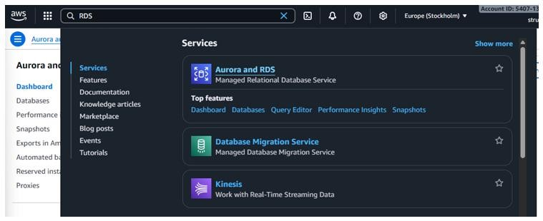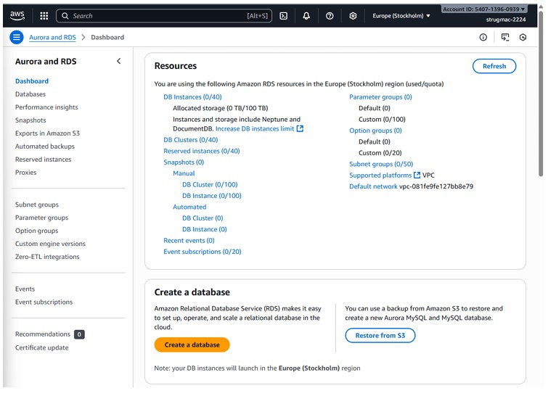

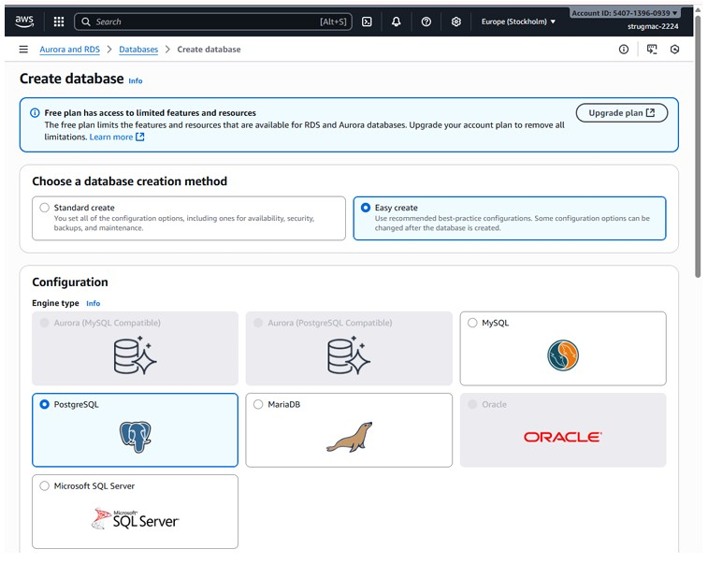
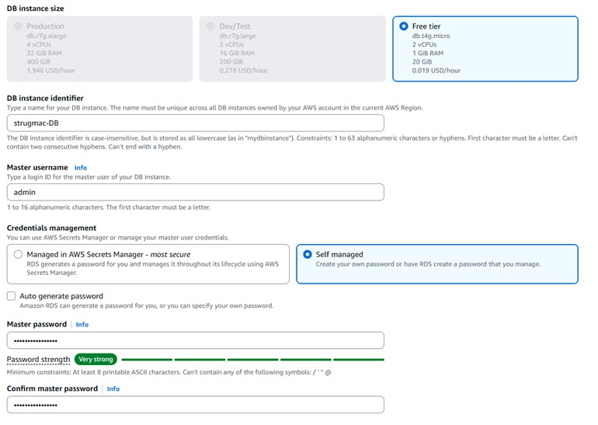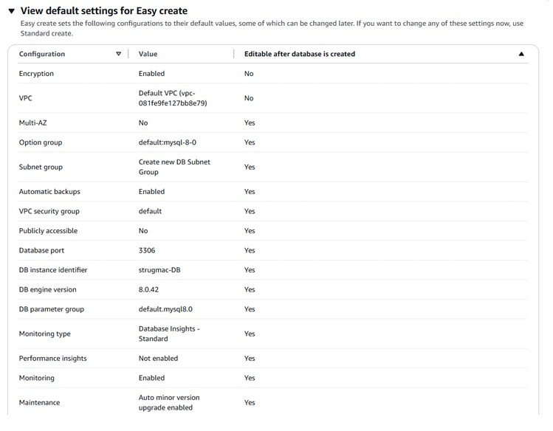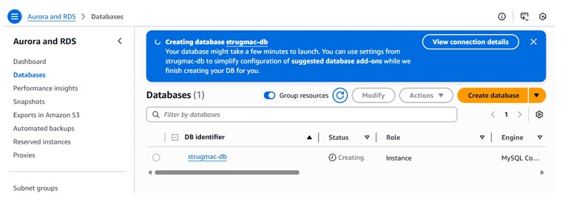

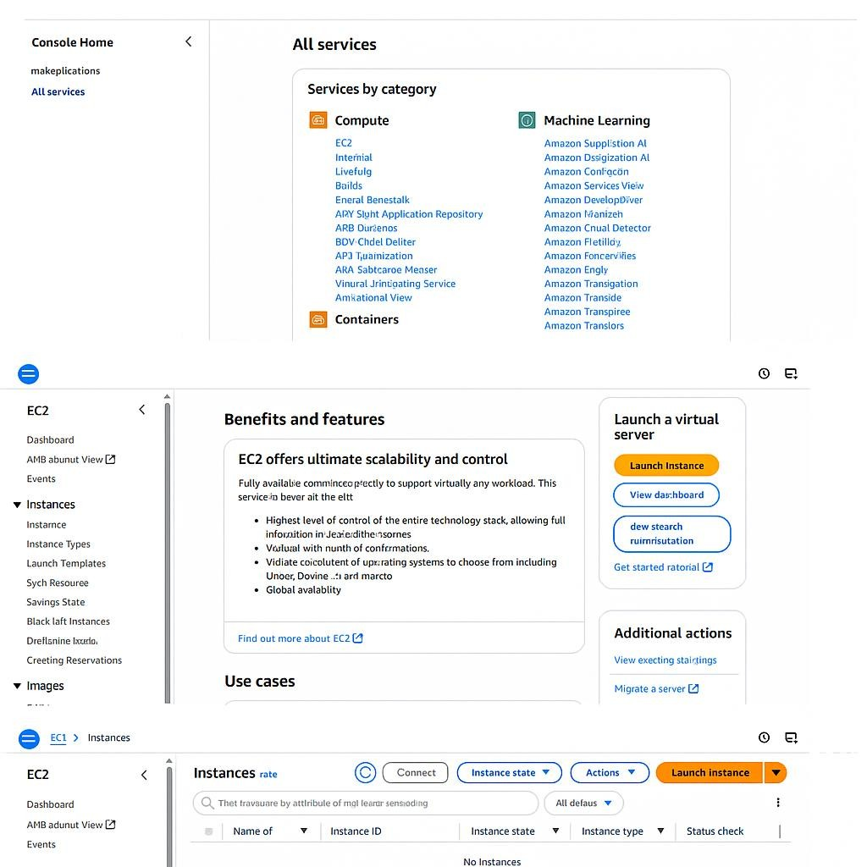
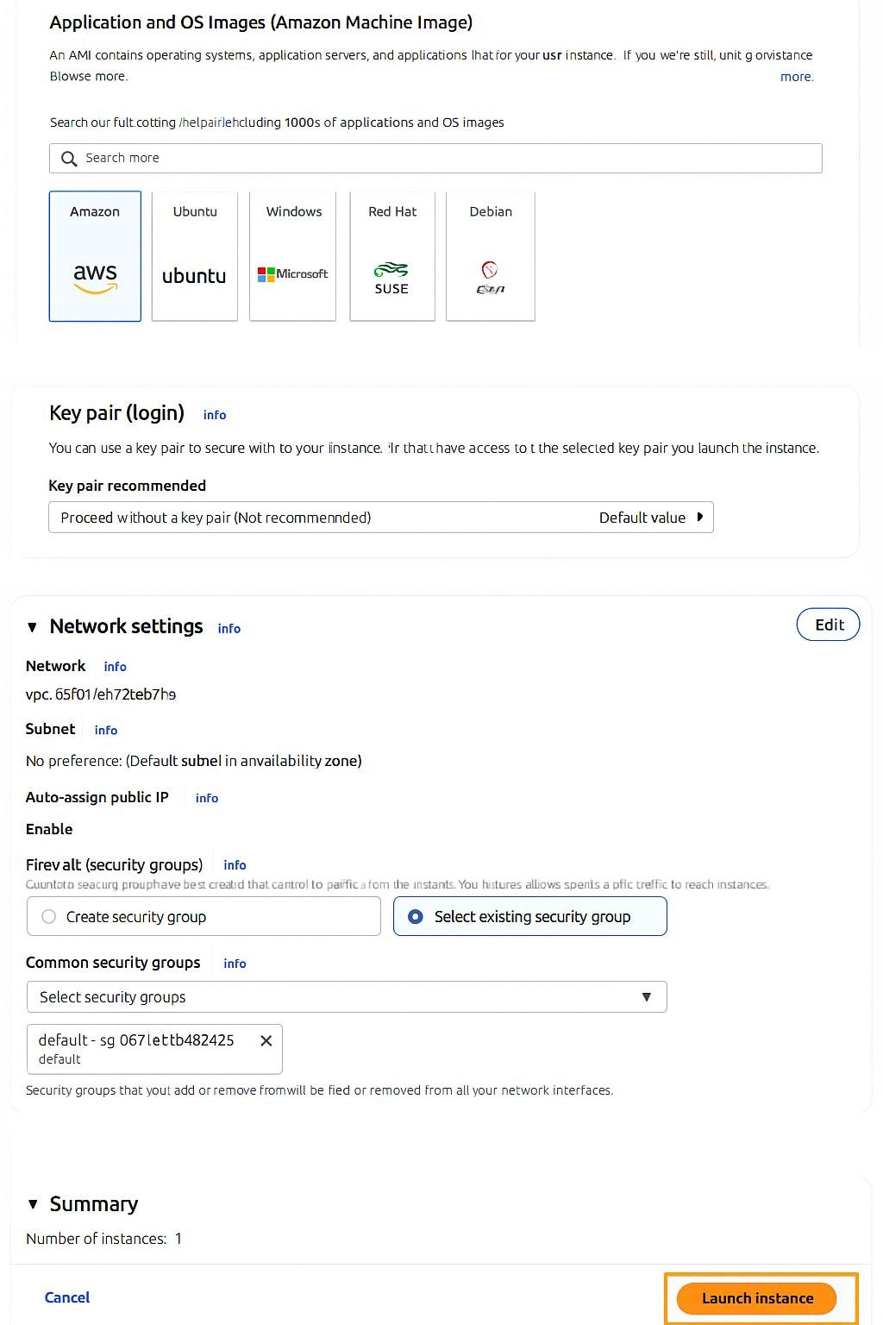
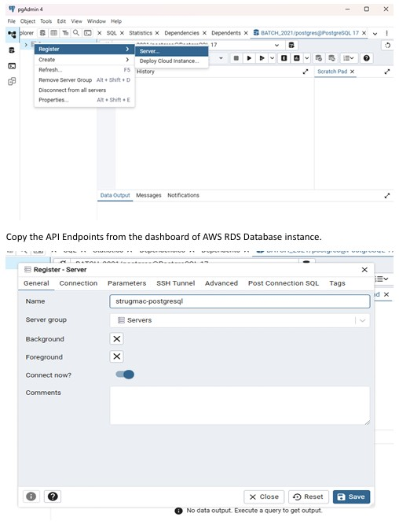
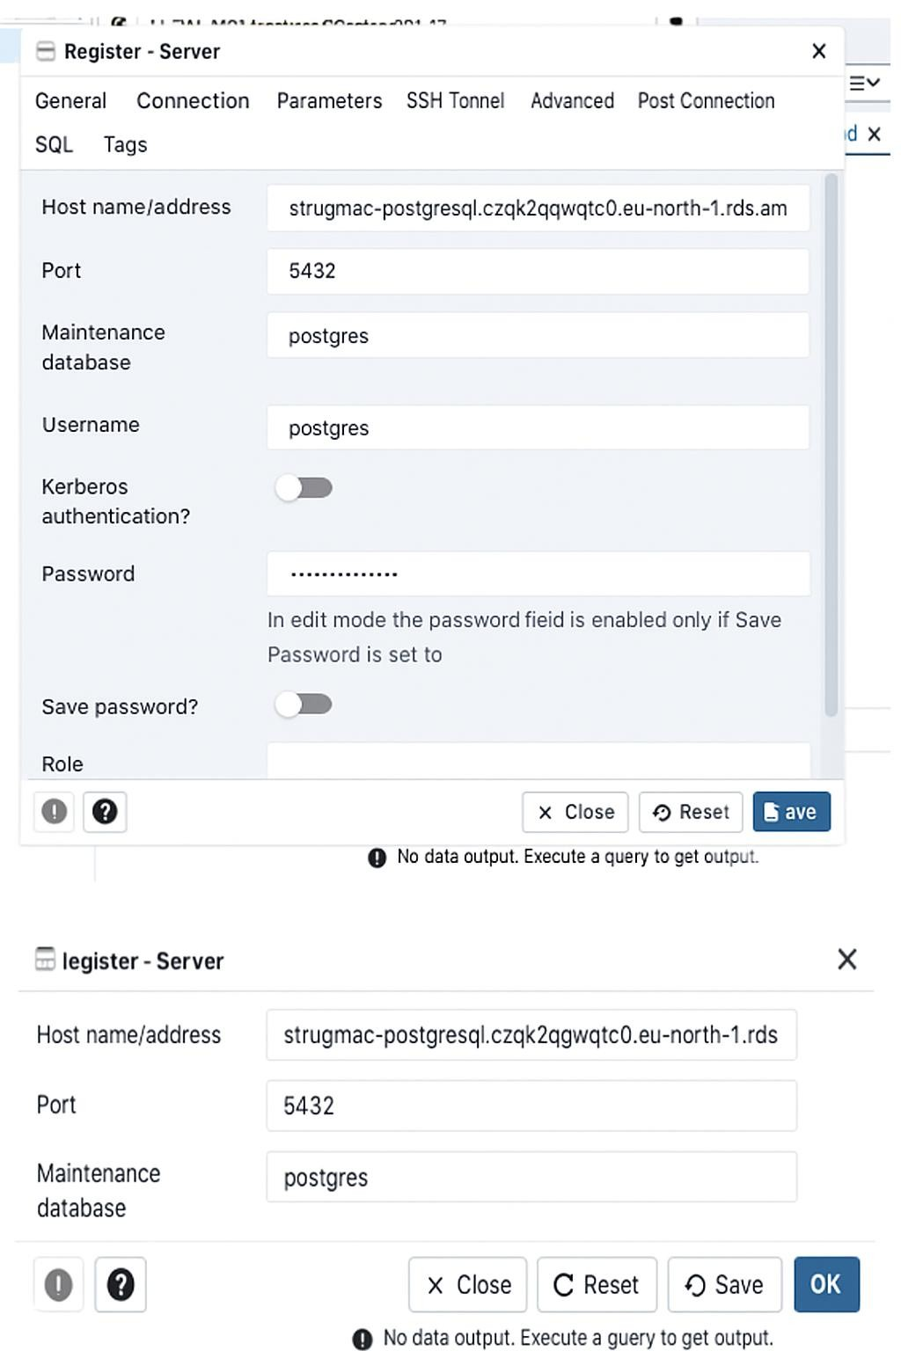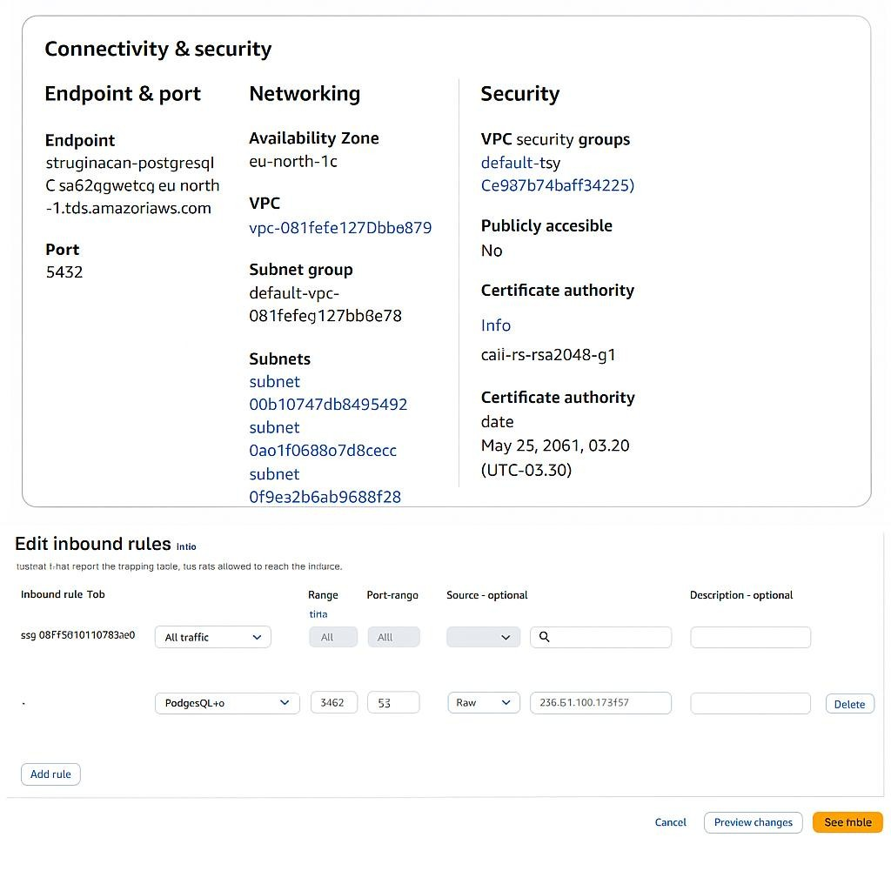

- Learning Outcomes:
- Understood the concept and functionality of Amazon RDS (Relational Database Service).
- Learned how to create and configure a database instance on AWS RDS.
- Gained practical knowledge of connecting AWS RDS with local pgAdmin/MySQL Workbench.
- Understood how to set up and modify VPC security groups to manage inbound and outbound traffic.
- Learned to edit inbound rules to allow database access from specific IP addresses securely.
- Understood the importance of network configuration and security in cloud database management.
- Learned to troubleshoot common connectivity errors like “connection timeout expired.” • Gained experience in launching and configuring EC2 instances for database connectivity.
- Understood differences between databases on EC2 and AWS RDS in terms of scalability and maintenance.
- Developed the ability to deploy, manage, and secure cloud-based relational databases effectively.

